
Washington Plaza Baptist Church
2026 Stewardship Campaign Pledge Form
Having a Faithful, Hopeful, Loving Heart
Form for Time and Talents

How will God be leading you to invest in the Ministry(ies)
at Washington Plaza Baptist Church in 2026?

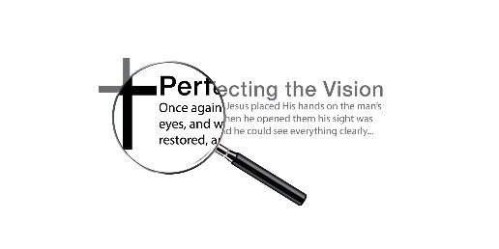
All members and friends are invited to participate in the ministries of our church. Please mark the ministry(ies) you would like to participate in and/or learn more about. Someone from the Church Council will contact you to share more information.
- Finance & Missions Ministry
Oversee the church's financial well-being and ensure accountability in financial practices. Plan and lead an annual stewardship campaign, coordinate mission-focused offerings such as First Sunday gifts, and organize service activities within the Reston community and beyond. Plan for mission giving, allocating mission funds to support those in need within our church family and our extended community.

- Facilities Ministry
Oversee the maintenance of the building; organize and lead church workdays twice a year; work with Trustees to make decisions about the priorities for building upkeep.

- Worship & Music Ministry
Work with our Pastor to support the Music and Worship for our Sunday services. Enlist volunteers as readers, liturgists, and ushers. Decorate the altar and sanctuary (flowers, banners, etc.) and assist our Pastor in planning special/seasonal services. Work with our Pastor to coordinate and lead creative musical offerings and help schedule guest musicians.
- Outreach & Hospitality Ministry
Plan unique outreach events and participate in events on the Plaza; maintain and develop our promotional materials and signage; plan and conduct fellowship opportunities for our church and surrounding community. Maintain, develop, and enhance our social media presence.

Name__________________________________________

Best Way to Contact You:
Cell Phone:_________________
Work Phone:________________
Email:_____________________

Thank you for sharing your Time, Talent, and Tithes with WPBC!

