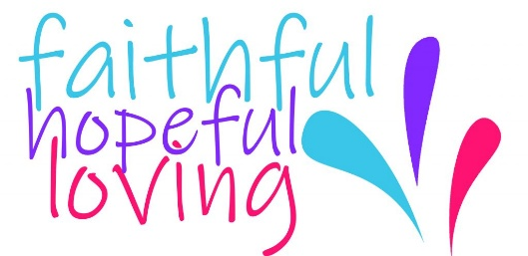


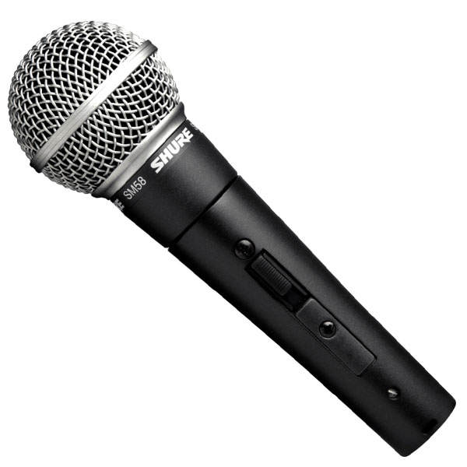

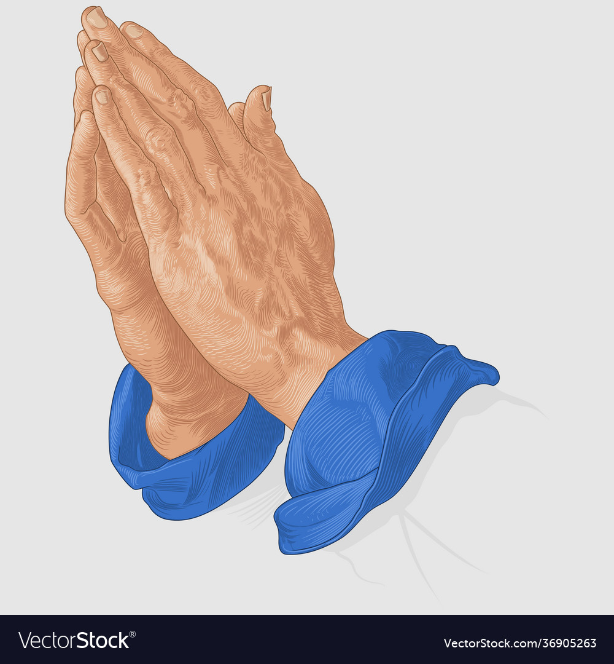

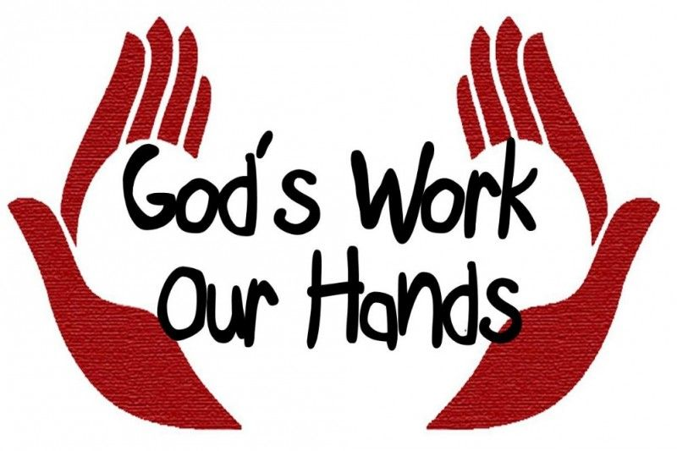


Washington Plaza Baptist Church
2026 Stewardship Campaign Pledge Form
Having a Faithful, Hopeful, Loving Heart
Form for Pledges

And now these three remain: faith, hope and love.
But the greatest of these is love.
1 Corinthians 13:13

Name(s) _____________________________________________________

Address _____________________________________________________

I/we desire to share our gifts by financially supporting Washington Plaza Baptist church.

TOTAL YEARLY GIFT TO THE 2026 BUDGET: $_______________

2026 Budget Pledge Plan: (Select one approach)

$_____________ Weekly Gift for 52 weeks

$_____________ Monthly Gift for 12 months

$_____________ Quarterly Gift

$_____________ Annual Gift

$_____________ Gift according to the following schedule:

_______________________________________________________________________

____ Please check here and someone from the Finance Ministry will contact you with information on how to remember Washington Plaza Baptist Church in your estate planning.

Donations can be made in person on Sundays, through the mail and online.

Signature(s):_________________________ Phone: _________________ Date: _______

You may change or update your pledge
at any time during the year.

Thank you.

Please bring this form to our Pledge Service on Sunday, November 16, 2025
or the church office by Friday, November 14, 2025.

